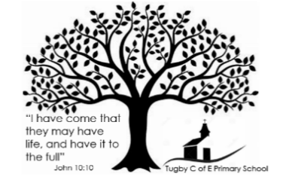
Books and Hymns Linked to our Values

Value | Hymn | Book
Hope  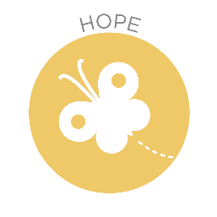 | Give me oil in my lamp  Give me oil in my lamp | Christian Songs For Kids (youtube.com) | Rain Before Rainbows – David Litchfield  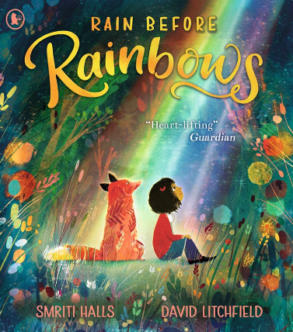
Love   | All things bright and Beautiful  All Things Bright And Beautiful by Kidzup with lyrics - YouTube | Bloom – Ann Booth and Robyn Wilson-Owen  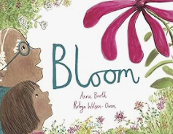
Forgiveness  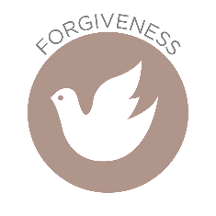 | Amazing Grace  Alan Jackson- Amazing Grace (Lyrics) - YouTube | Art & Max - David  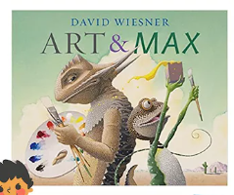
Trust  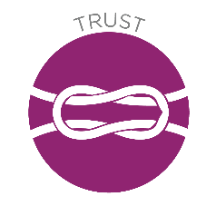 | My Lighthouse  My Lighthouse with lyrics (Rend Collective) (youtube.com) | The Koala Who Could – Rachel Bright  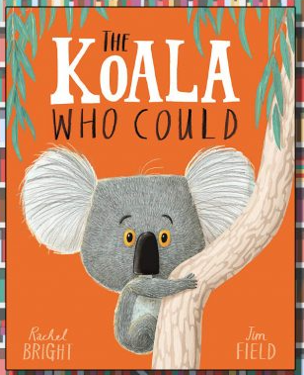
Truthfulness  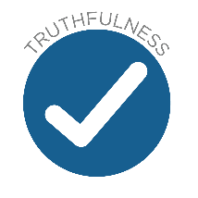 | This Little Light of Mine  "This Little Light Of Mine" (youtube.com) | Finn’s Little Fibs – Tom Percival  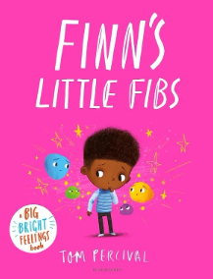
Respect   | Love one another  Love One Another (youtube.com) | Leaf – Sandra Dieckmann  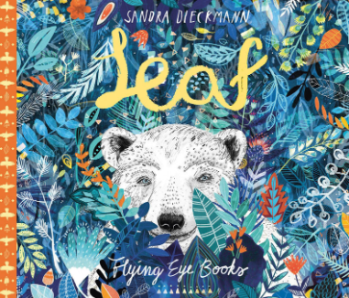
*  Courageous Advocacy | Shine  Shine (From the Inside Out) - Remix - Children's Sing Along Worship Lyric Video - YouTube | Dare – Polly Noakes  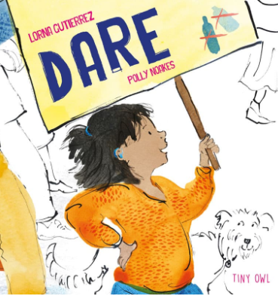
Celebration  Assembly | Altogether as a Family  All together as a family - BBC Teach | The Magic Paintbrush – Julia Donaldson  

