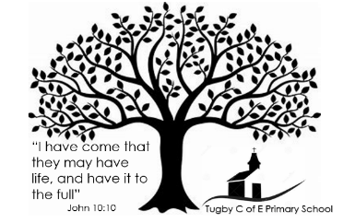
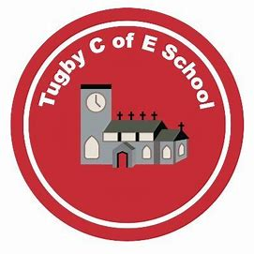
Collective Worship at Tugby C of E Primary School

Collective worship is a fundamental part of every day in school, worship at Tugby happens each afternoon at 3.05pm and gives all pupils and staff a chance to reflect on their day. All staff and pupils attend worship.
Our worship focuses on a different theme each week or fortnight and these are organised across the term by the Rise Collective Worship Lead. You can see the themes in our Collective Worship plan.
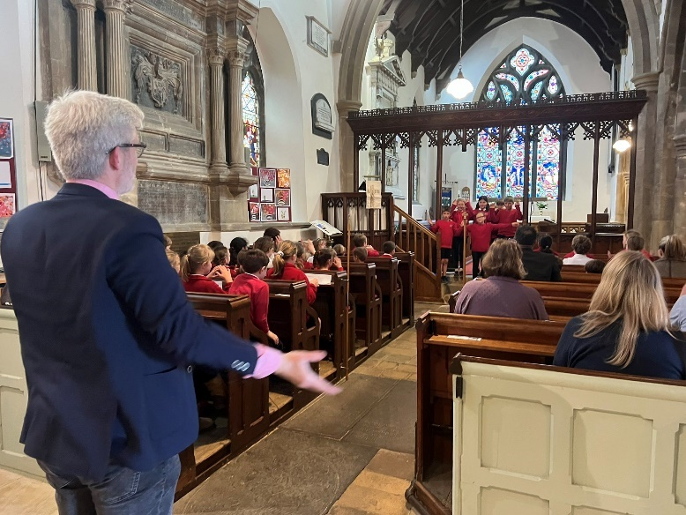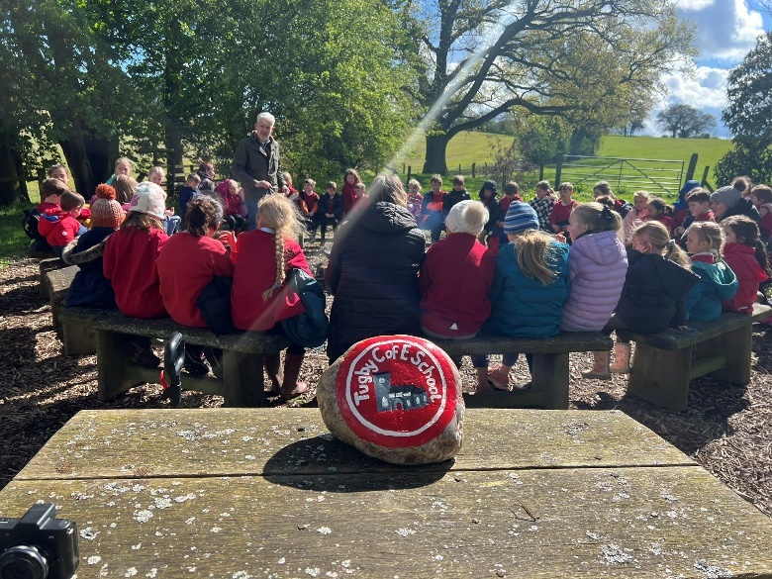
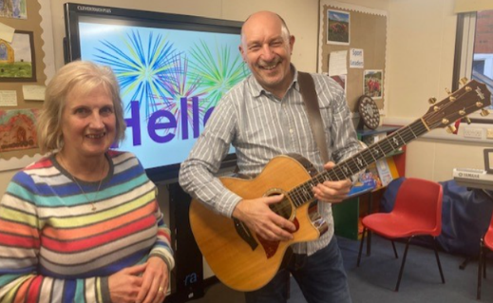
Every fortnight the Billesdon Chapel Centre come into school to lead Collective Worship, this year they will look at “The Big Questions” based on the questions they have been asked in “Ask Brian”, using this bible verse as the theme:
“If you need wisdom, ask our generous God, and he will give it to you.” (James 1:5)

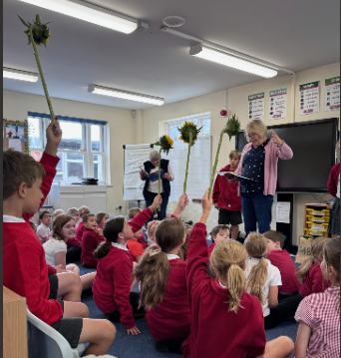
We are also joined by The Open the Book team who share bible stories with the children once a month. They invite the children to the front of the class and encourage them to act out stories from the bible.
Our school vision and values are a common thread throughout our worship time, we have four Collective Worship sessions a week. We also have an additional Certificate Assembly that takes place on a Friday afternoon where we celebrate children’s achievement, attendance, behaviour and our Christian Values. Parents are invited to attend our Collective Worship once a month along with multiple opportunities to also come into school to celebrate our pupils and for key events throughout the year.


